**Main analysis**

**Prevalent Cases**

**Total cases meeting any inclusion criteria as identified by Population Data BC, N= 231,344**

|  |  |  |  |
| --- | --- | --- | --- |
| Model | **Base model** | More specific | **Cohort size (n)** |
| 1 | **DAD**  ICD10 I48 (AF/AFL) | DAD | n=135,925 |
| 2 | **NACRS** (CED-DxS)  ICD10 I48 (AF/AFL) | Add NACRS | Subgroup n= 18,702  Additional (to DAD) n=  Total (1+2) n= 143,552 |
| 3 | **AF highly specific rhythm control**  dronedarone; propafenone; disopyramide; flecainide |  | Subgroup n= 23,523  Additional (to DAD/NACRS) n=  Total (1+2+3) n=151,127 |
|  | **Supplemental model** | Less specific |  |
|  | One physician billing (MSP BC)  Dx code ICD9 427.3 AF  Plus one factor within 2 years to increase specificity: | 1 MSP | Subgroup n= 158,969  Additional (to base model 3) n= 66,690  Total = 217,817 |
| 4 | A) AF moderately specific rhythm control: sotalol or amiodarone | 1 MSP + sot/amio | Subgroup n= 24,415  Additional (to base model 3) n= 3,599  Total (1+2+3+4) n=154,452 |
| 5 | B) Cardioversion | 1 MSP + cardioversion | Subgroup n= 7,152  Additional (to base model 3) n= 433  Total (1+2+3+4+5) n= 154787 |
| 6 | C) Ablation | 1 MSP + ablation | Subgroup n= 1,527  Additional (to base model 3) n= 4  Total (1+2+3+4+5+6) n= 154,791 |
| 7 | D) Oral anticoagulation (VKA or NOAC) | 1 MSP + OAC | Subgroup n= 38,434  Additional (to base model 3) n=11,662  Total (1+2+3+4+5+6+7) n=165,431 |
| 8 | E) Second MSP code minimum 30 days apart | 2 MSP 30 days apart | Subgroup n=81,986  Additional (to base model 3) n= 25955  Total=182,033 |

|  |  |  |  |
| --- | --- | --- | --- |
| Model | **Base model** | More specific | **Cohort size (n)** |
| 1 | **DAD**  ICD10 I48 (AF/AFL) | DAD | n=135,925 |
| 2 | **NACRS** (CED-DxS)  ICD10 I48 (AF/AFL) | Add NACRS | Subgroup n= 18,702  Additional (to DAD) n=  Total (1+2) n= 143,552 |
| 3 | **AF highly specific rhythm control**  dronedarone; propafenone; disopyramide; flecainide |  | Subgroup n= 23,523  Additional (to DAD/NACRS) n=  Total (1+2+3) n=151,127 |
|  | **Supplemental model** | Less specific |  |
|  | One physician billing (MSP BC)  Dx code ICD9 427.3 AF  Plus one factor within 2 years to increase specificity: | 1 MSP | Subgroup n= 158,969  Additional (to base model 3) n= 66,690  Total = 217,817 |
| 8 | E) Second MSP code minimum 30 days apart | 2 MSP 30 days apart | Subgroup n=81,986  Additional (to base model 3) n= 25955  Total=176,835 |
| 4 | A) AF moderately specific rhythm control: sotalol or amiodarone | 1 MSP + sot/amio | Subgroup n= 24,415  Additional (to base model 3) n= 3,599  Total (1+2+3+4) n=178,208 |
| 5 | B) Cardioversion | 1 MSP + cardioversion | Subgroup n= 7,152  Additional (to base model 3) n= 433  Total (1+2+3+4+5) n= 178,343 |
| 6 | C) Ablation | 1 MSP + ablation | Subgroup n= 1,527  Additional (to base model 3) n= 4  Total (1+2+3+4+5+6) n= 178,345 |
| 7 | D) Oral anticoagulation (VKA or NOAC) | 1 MSP + OAC | Subgroup n= 38,434  Additional (to base model 3) n=11,662  Total (1+2+3+4+5+6+7) n= 182,033 |

**Alternate Order:**

**Prevalent Cases**

**Total cases meeting any inclusion criteria as identified by Population Data BC, N= 231,344**

**Alternate Order – 2 :**

**Prevalent Cases**

**Total cases meeting any inclusion criteria as identified by Population Data BC, N= 231,344**

|  |  |  |  |
| --- | --- | --- | --- |
| Model | **Base model** | More specific | **Cohort size (n)** |
| 1 | **DAD**  ICD10 I48 (AF/AFL) | DAD | n=135,515 |
| 2 | **NACRS** (CED-DxS)  ICD10 I48 (AF/AFL) | Add NACRS | Subgroup n= 18,705  Additional (to DAD) n= 7,628  Total (1+2) n= 143,636 |
|  | **Supplemental model** | Less specific |  |
| 3 | E) Second MSP code minimum 30 days apart | 2 MSP 30 days apart | Subgroup n= 81,986  Additional (to base model 2) n= 28,401  Total (1+2+3) n= 172,037 |
| 5 | **AF highly specific rhythm control**  dronedarone; propafenone; |  | Subgroup n=  Additional (to model 3) n= 4,247  Total (1+2+3+5) n= 176,284 |

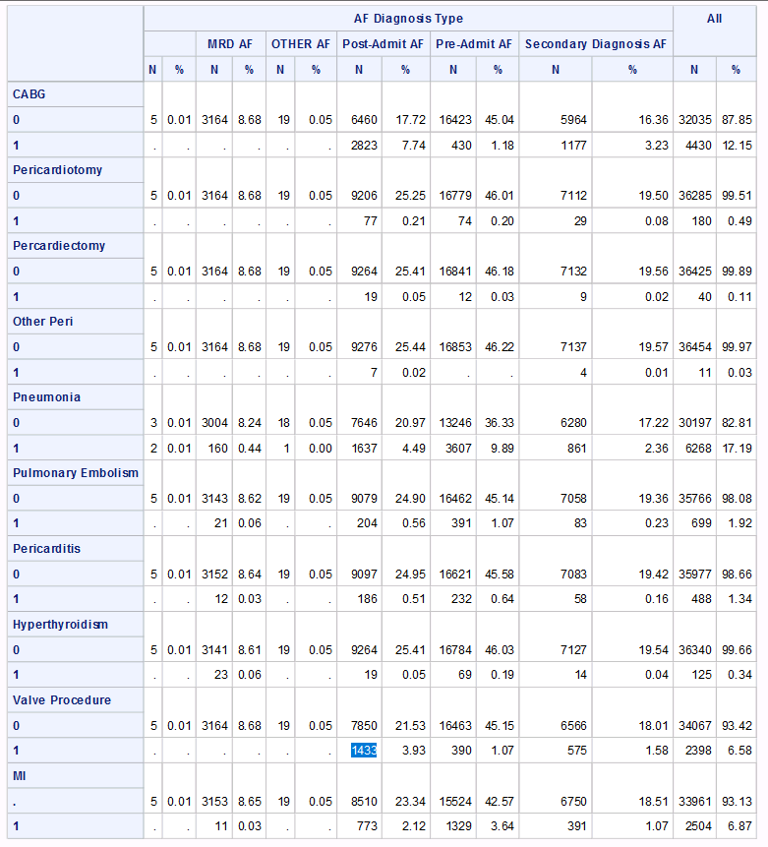

**Additional analyses**

1) Compare time frame for codes/drugs/procedures: 1/2/3/4/5 years.

A) Interested if interaction between time frame and proportion identified by inpatient and outpatient data sources. Shorter (e.g. 1 year) lower probability of acute care episode and therefore greater reliance on MSP coding.

B) Define incremental increase in sample size with increasing time frame. e.g. Presume 3 years identifies larger population, possibly diminishing returns with 5 vs 3 years.

2) Patients entering province.

A) What proportion of patients enter the province (proportion of prevalence).

B) What is the time distribution of incident diagnoses after entering the province.

How should ‘incident’ be decided for patients entering province with no retrospective time frame to exclude ‘prevalent’ disease.

3) Coding position.

DAD. MRP vs pre-existing vs post-admission.

4) MSP fee codes.

Type (Frequencies/%). e.g. consult, office visit.

Practitioner (Frequencies/%). e.g. Primary care, internal medicine, cardiology, other.